**Create Eureka Discovery Server and register microservices**

**STRUCTURE:**

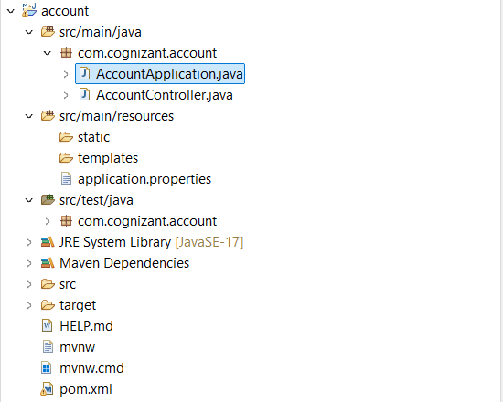

**CODE:**

**AccountApplication.java:**

package com.cognizant.account;

import org.springframework.boot.SpringApplication;

import org.springframework.boot.autoconfigure.SpringBootApplication;

import org.springframework.cloud.client.discovery.EnableDiscoveryClient;

@SpringBootApplication

@EnableDiscoveryClient

public class AccountApplication {

public static void main(String[] args) {

SpringApplication.*run*(AccountApplication.class, args);

}

}

**AccountController.java:**

package com.cognizant.account;

import org.springframework.web.bind.annotation.*;

@RestController

public class AccountController {

@GetMapping("/accounts/{number}")

public Account getAccountDetails(@PathVariable String number) {

return new Account(number, "savings", 234343);

}

// Inner class to simulate account data

class Account {

private String number;

private String type;

private double balance;

public Account(String number, String type, double balance) {

this.number = number;

this.type = type;

this.balance = balance;

}

public String getNumber() { return number; }

public String getType() { return type; }

public double getBalance() { return balance; }

}

}

**application.properties:**

server.port=8012

spring.application.name=account-service

eureka.client.service-url.defaultZone=http://localhost:8760/eureka

**pom.xml:**

<project xmlns="http://maven.apache.org/POM/4.0.0"

xmlns:xsi="http://www.w3.org/2001/XMLSchema-instance"

xsi:schemaLocation="http://maven.apache.org/POM/4.0.0

http://maven.apache.org/xsd/maven-4.0.0.xsd">

<modelVersion>4.0.0</modelVersion>

<groupId>com.cognizant</groupId>

<artifactId>account</artifactId>

<version>0.0.1-SNAPSHOT</version>

<packaging>jar</packaging>

<name>account</name>

<description>Account Microservice for Eureka Discovery</description>

<parent>

<groupId>org.springframework.boot</groupId>

<artifactId>spring-boot-starter-parent</artifactId>

<version>3.1.5</version> <!-- or compatible version you use -->

<relativePath/> <!-- lookup parent from repository -->

</parent>

<properties>

<java.version>17</java.version> <!-- or 11 if your system supports it -->

<spring-cloud.version>2022.0.5</spring-cloud.version> <!-- Compatible with Spring Boot 3.1 -->

</properties>

<dependencies>

<!-- Spring Web -->

<dependency>

<groupId>org.springframework.boot</groupId>

<artifactId>spring-boot-starter-web</artifactId>

</dependency>

<!-- Eureka Client -->

<dependency>

<groupId>org.springframework.cloud</groupId>

<artifactId>spring-cloud-starter-netflix-eureka-client</artifactId>

</dependency>

<!-- Dev Tools (optional) -->

<dependency>

<groupId>org.springframework.boot</groupId>

<artifactId>spring-boot-devtools</artifactId>

<scope>runtime</scope>

</dependency>

<!-- Testing (optional) -->

<dependency>

<groupId>org.springframework.boot</groupId>

<artifactId>spring-boot-starter-test</artifactId>

<scope>test</scope>

</dependency>

</dependencies>

<!-- Dependency Management for Spring Cloud -->

<dependencyManagement>

<dependencies>

<dependency>

<groupId>org.springframework.cloud</groupId>

<artifactId>spring-cloud-dependencies</artifactId>

<version>${spring-cloud.version}</version>

<type>pom</type>

<scope>import</scope>

</dependency>

</dependencies>

</dependencyManagement>

<build>

<plugins>

<plugin>

<groupId>org.springframework.boot</groupId>

<artifactId>spring-boot-maven-plugin</artifactId>

<version>3.1.5</version>

</plugin>

</plugins>

</build>

</project>

**Output:**

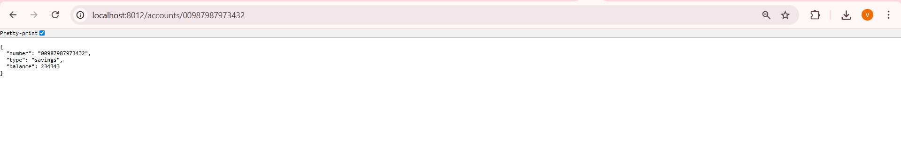

**STRUCTURE:**

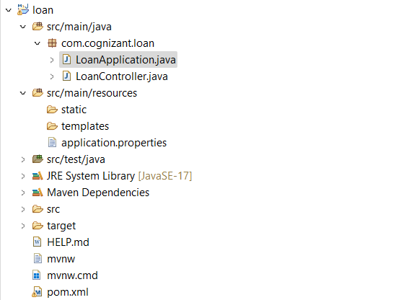

**CODE:**

**LoanApplication.java:**

package com.cognizant.loan;

import org.springframework.boot.SpringApplication;

import org.springframework.boot.autoconfigure.SpringBootApplication;

import org.springframework.cloud.client.discovery.EnableDiscoveryClient;

@SpringBootApplication

@EnableDiscoveryClient //

public class LoanApplication {

public static void main(String[] args) {

SpringApplication.*run*(LoanApplication.class, args);

}

}

**LoanController.java:**

package com.cognizant.loan;

import org.springframework.web.bind.annotation.*;

@RestController

public class LoanController {

@GetMapping("/loans/{number}")

public Loan getLoanDetails(@PathVariable String number) {

return new Loan(number, "car", 400000, 3258, 18);

}

class Loan {

private String number;

private String type;

private double loan;

private int emi;

private int tenure;

public Loan(String number, String type, double loan, int emi, int tenure) {

this.number = number;

this.type = type;

this.loan = loan;

this.emi = emi;

this.tenure = tenure;

}

public String getNumber() { return number; }

public String getType() { return type; }

public double getLoan() { return loan; }

public int getEmi() { return emi; }

public int getTenure() { return tenure; }

}

}

**application.properties:**

spring.application.name=loan-service

server.port=8095

eureka.client.service-url.defaultZone=http://localhost:8760/eureka/

eureka.client.register-with-eureka=true

eureka.client.fetch-registry=true

**pom.xml:**

<project xmlns="http://maven.apache.org/POM/4.0.0"

xmlns:xsi="http://www.w3.org/2001/XMLSchema-instance"

xsi:schemaLocation="http://maven.apache.org/POM/4.0.0

http://maven.apache.org/xsd/maven-4.0.0.xsd">

<modelVersion>4.0.0</modelVersion>

<groupId>com.cognizant</groupId>

<artifactId>loan</artifactId>

<version>0.0.1-SNAPSHOT</version>

<packaging>jar</packaging>

<name>loan</name>

<description>Loan Microservice</description>

<parent>

<groupId>org.springframework.boot</groupId>

<artifactId>spring-boot-starter-parent</artifactId>

<version>3.1.2</version>

<relativePath/> <!-- lookup parent from repository -->

</parent>

<properties>

<java.version>17</java.version>

</properties>

<dependencies>

<!-- Spring Web -->

<dependency>

<groupId>org.springframework.boot</groupId>

<artifactId>spring-boot-starter-web</artifactId>

</dependency>

<!-- Eureka Client -->

<dependency>

<groupId>org.springframework.cloud</groupId>

<artifactId>spring-cloud-starter-netflix-eureka-client</artifactId>

</dependency>

<!-- DevTools (optional for hot reload) -->

<dependency>

<groupId>org.springframework.boot</groupId>

<artifactId>spring-boot-devtools</artifactId>

<scope>runtime</scope>

</dependency>

<!-- Testing -->

<dependency>

<groupId>org.springframework.boot</groupId>

<artifactId>spring-boot-starter-test</artifactId>

<scope>test</scope>

</dependency>

</dependencies>

<build>

<plugins>

<plugin>

<groupId>org.springframework.boot</groupId>

<artifactId>spring-boot-maven-plugin</artifactId>

<version>3.1.2</version>

</plugin>

</plugins>

</build>

<dependencyManagement>

<dependencies>

<dependency>

<groupId>org.springframework.cloud</groupId>

<artifactId>spring-cloud-dependencies</artifactId>

<version>2022.0.4</version>

<type>pom</type>

<scope>import</scope>

</dependency>

</dependencies>

</dependencyManagement>

<repositories>

<repository>

<id>spring-releases</id>

<name>Spring Releases</name>

<url>https://repo.spring.io/release</url>

</repository>

</repositories>

</project>

**Output:**

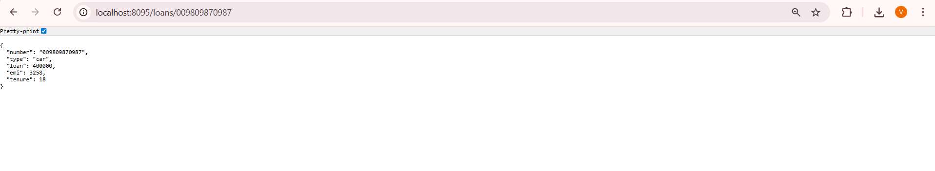

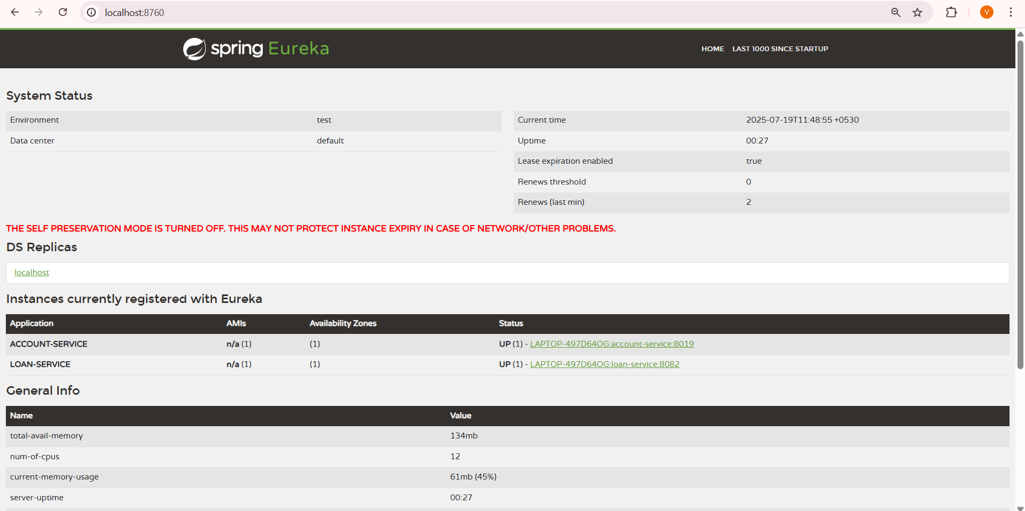

**STRUCTURE:**

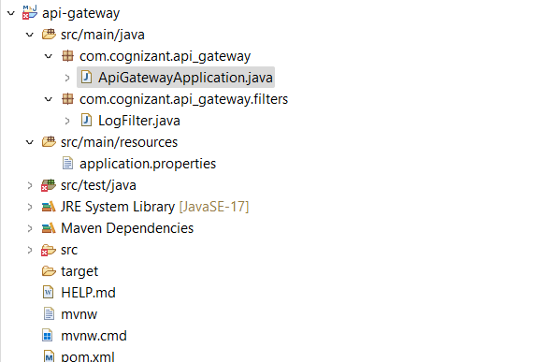

**ApiGatewayApplication.java:**

package com.cognizant.api_gateway;

import org.springframework.boot.SpringApplication;

import org.springframework.boot.autoconfigure.SpringBootApplication;

import org.springframework.cloud.client.discovery.EnableDiscoveryClient;

@SpringBootApplication

@EnableDiscoveryClient

public class ApiGatewayApplication {

public static void main(String[] args) {

SpringApplication.*run*(ApiGatewayApplication.class, args);

}

}

**LogFilter.java:**

package com.cognizant.api_gateway.filters;

import org.slf4j.Logger;

import org.slf4j.LoggerFactory;

import org.springframework.cloud.gateway.filter.GatewayFilterChain;

import org.springframework.cloud.gateway.filter.GlobalFilter;

import org.springframework.core.Ordered;

import org.springframework.stereotype.Component;

import org.springframework.web.server.ServerWebExchange;

import reactor.core.publisher.Mono;

@Component

public class LogFilter implements GlobalFilter, Ordered {

private static final Logger *logger* = LoggerFactory.*getLogger*(LogFilter.class);

@Override

public Mono<Void> filter(ServerWebExchange exchange, GatewayFilterChain chain) {

*logger*.info("Incoming request: {}", exchange.getRequest().getURI());

return chain.filter(exchange);

}

@Override

public int getOrder() {

return -1; // Highest priority

}

}

**application.properties:**

# Port for Gateway

server.port=9090

# App name for Eureka

spring.application.name=api-gateway

# Eureka Service Registry URL

eureka.client.service-url.defaultZone=http://localhost:8760/eureka

# Enable service discovery-based routing

spring.cloud.gateway.discovery.locator.enabled=true

spring.cloud.gateway.discovery.locator.lower-case-service-id=true

**pom.xml:**

<project xmlns="http://maven.apache.org/POM/4.0.0"

xmlns:xsi="http://www.w3.org/2001/XMLSchema-instance"

xsi:schemaLocation="http://maven.apache.org/POM/4.0.0

http://maven.apache.org/xsd/maven-4.0.0.xsd">

<modelVersion>4.0.0</modelVersion>

<groupId>com.example</groupId>

<artifactId>api-gateway</artifactId>

<version>0.0.1-SNAPSHOT</version>

<name>api-gateway</name>

<description>Spring Cloud API Gateway</description>

<parent>

<groupId>org.springframework.boot</groupId>

<artifactId>spring-boot-starter-parent</artifactId>

<version>3.1.9</version>

</parent>

<properties>

<java.version>17</java.version>

</properties>

<dependencies>

<!-- API Gateway -->

<dependency>

<groupId>org.springframework.cloud</groupId>

<artifactId>spring-cloud-starter-gateway</artifactId>

</dependency>

<!-- Eureka Discovery Client -->

<dependency>

<groupId>org.springframework.cloud</groupId>

<artifactId>spring-cloud-starter-netflix-eureka-client</artifactId>

</dependency>

<!-- DevTools -->

<dependency>

<groupId>org.springframework.boot</groupId>

<artifactId>spring-boot-devtools</artifactId>

<scope>runtime</scope>

</dependency>

<!-- Logging -->

<dependency>

<groupId>org.slf4j</groupId>

<artifactId>slf4j-api</artifactId>

</dependency>

</dependencies>

<dependencyManagement>

<dependencies>

<dependency>

<groupId>org.springframework.cloud</groupId>

<artifactId>spring-cloud-dependencies</artifactId>

<version>2022.0.4</version>

<type>pom</type>

<scope>import</scope>

</dependency>

</dependencies>

</dependencyManagement>

<build>

<plugins>

<plugin>

<groupId>org.springframework.boot</groupId>

<artifactId>spring-boot-maven-plugin</artifactId>

</plugin>

</plugins>

</build>

</project>

**Output:**

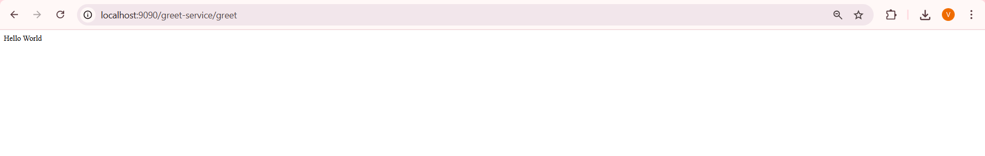

**STRUCTURE:**

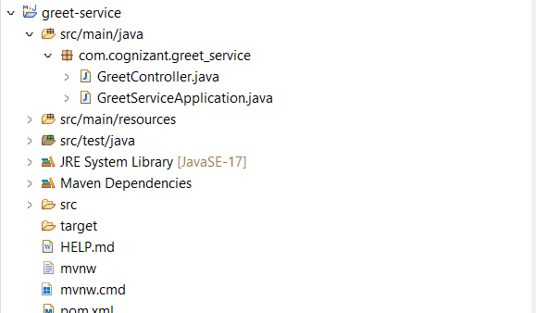

**CODE:**

**GreetController.java:**

package com.cognizant.greet_service;

import org.springframework.web.bind.annotation.GetMapping;

import org.springframework.web.bind.annotation.RestController;

@RestController

public class GreetController {

@GetMapping("/greet")

public String greet() {

return "Hello World";

}

}

**GreetServiceApplication.java:**

package com.cognizant.greet_service;

import org.springframework.boot.SpringApplication;

import org.springframework.boot.autoconfigure.SpringBootApplication;

import org.springframework.cloud.client.discovery.EnableDiscoveryClient;

@SpringBootApplication

@EnableDiscoveryClient

public class GreetServiceApplication {

public static void main(String[] args) {

SpringApplication.*run*(GreetServiceApplication.class, args);

}

}

**application.properties:**

server.port=8024

spring.application.name=greet-service

eureka.client.service-url.defaultZone=http://localhost:8760/eureka

**pom.xml:**

<project xmlns="http://maven.apache.org/POM/4.0.0"

xmlns:xsi="http://www.w3.org/2001/XMLSchema-instance"

xsi:schemaLocation="http://maven.apache.org/POM/4.0.0

http://maven.apache.org/xsd/maven-4.0.0.xsd">

<modelVersion>4.0.0</modelVersion>

<groupId>com.example</groupId>

<artifactId>greet-service</artifactId>

<version>0.0.1-SNAPSHOT</version>

<name>greet-service</name>

<description>Spring Boot Greet Service with Eureka</description>

<packaging>jar</packaging>

<parent>

<groupId>org.springframework.boot</groupId>

<artifactId>spring-boot-starter-parent</artifactId>

<version>3.1.9</version>

<relativePath/> <!-- lookup parent from repository -->

</parent>

<properties>

<java.version>17</java.version> <!-- or 21 if you're using Java 21 -->

</properties>

<dependencies>

<!-- Web Dependency -->

<dependency>

<groupId>org.springframework.boot</groupId>

<artifactId>spring-boot-starter-web</artifactId>

</dependency>

<!-- Eureka Discovery Client -->

<dependency>

<groupId>org.springframework.cloud</groupId>

<artifactId>spring-cloud-starter-netflix-eureka-client</artifactId>

</dependency>

<!-- DevTools for hot reload -->

<dependency>

<groupId>org.springframework.boot</groupId>

<artifactId>spring-boot-devtools</artifactId>

<scope>runtime</scope>

<optional>true</optional>

</dependency>

<!-- Test dependencies -->

<dependency>

<groupId>org.springframework.boot</groupId>

<artifactId>spring-boot-starter-test</artifactId>

<scope>test</scope>

</dependency>

</dependencies>

<dependencyManagement>

<dependencies>

<dependency>

<groupId>org.springframework.cloud</groupId>

<artifactId>spring-cloud-dependencies</artifactId>

<version>2022.0.4</version>

<type>pom</type>

<scope>import</scope>

</dependency>

</dependencies>

</dependencyManagement>

<build>

<plugins>

<plugin>

<groupId>org.springframework.boot</groupId>

<artifactId>spring-boot-maven-plugin</artifactId>

</plugin>

</plugins>

</build>

</project>

**Output:**



